**LAB 5 B**: Display Connector Status.

**Exercise 1**: Display the Configuration Manager connector status:

1. Sign in to [Microsoft Endpoint Manager admin center](https://go.microsoft.com/fwlink/?linkid=2109431).
2. Select **Tenant administration** > **Connectors and tokens** > **Microsoft Endpoint Configuration Manager**. Select a Configuration Manager hierarchy running version 2006, or later to display additional information about it.

[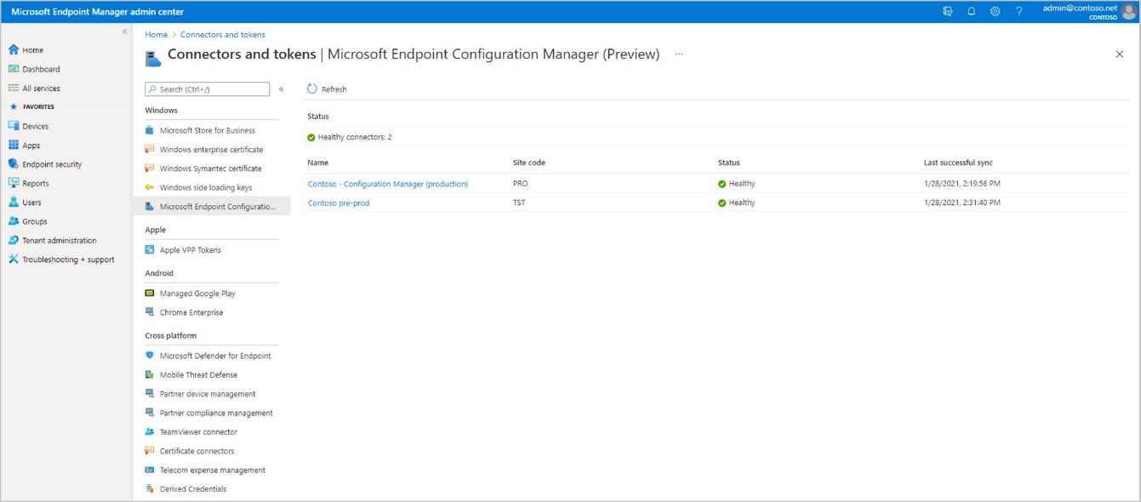](https://docs.microsoft.com/en-us/learn/m365/setup-tenant-attach-using-configuration-manager/media/set-up-tenant-attach-using-confirmation-manager-04.png#lightbox)

**Note**

Some information isn't available if the hierarchy is running Configuration Manager version 2006 or earlier.